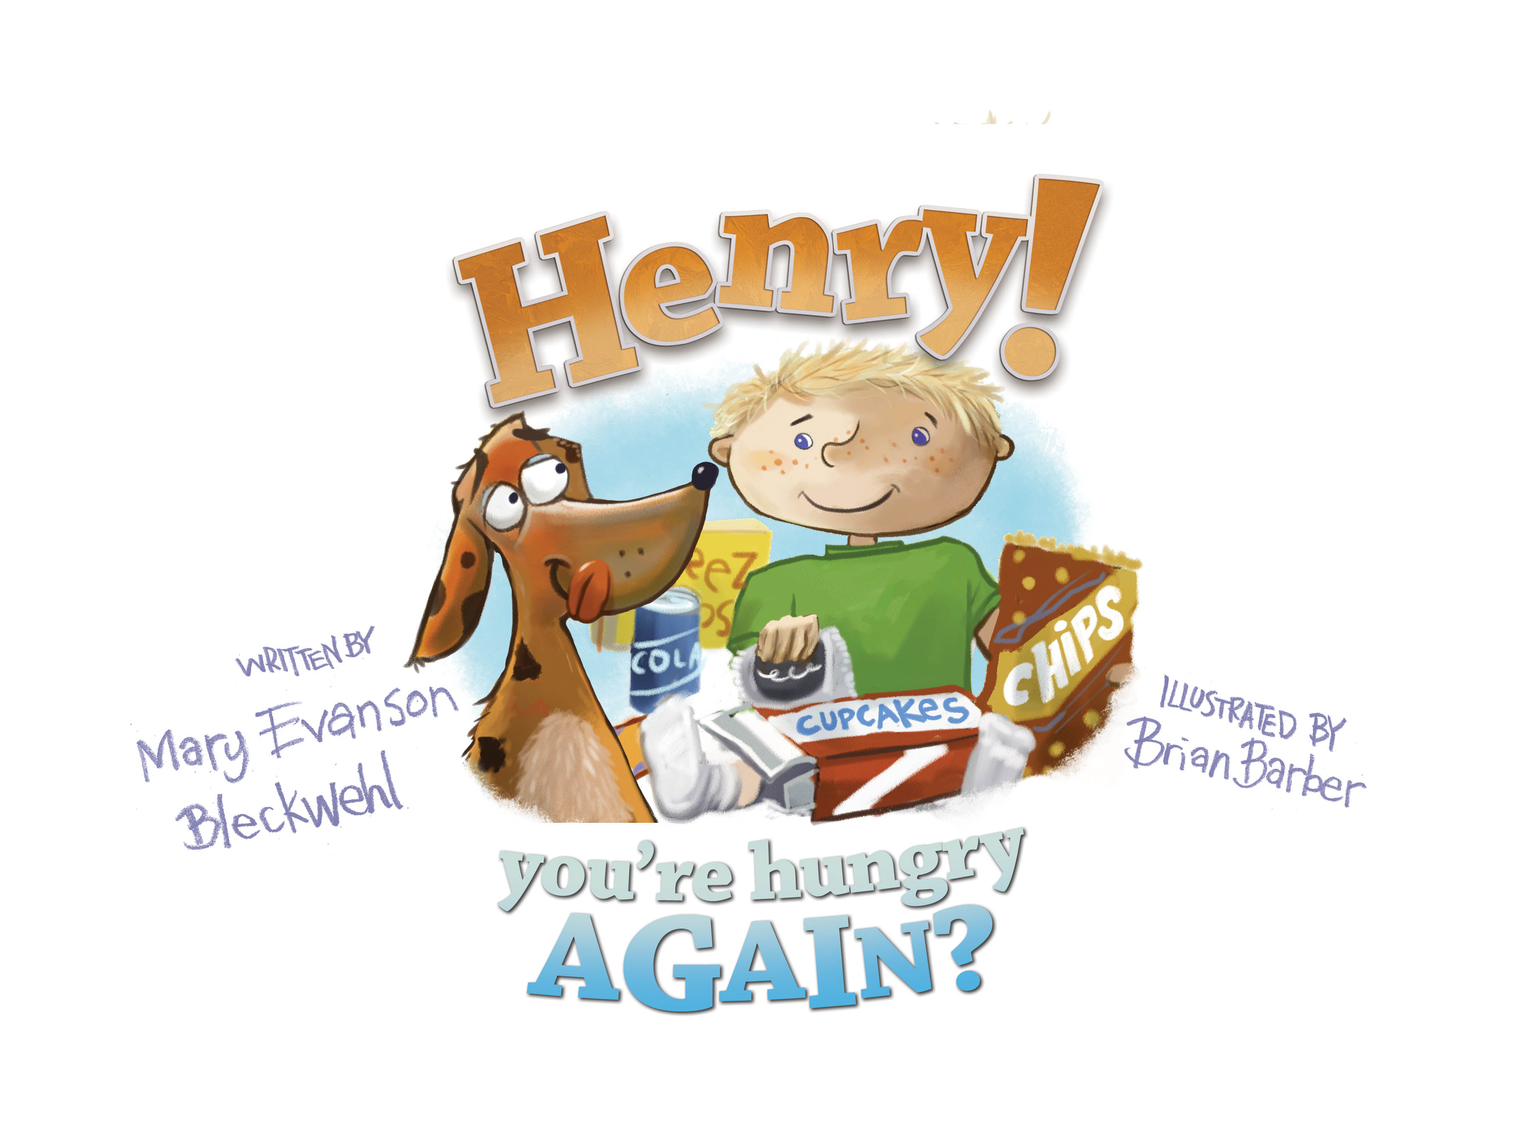
Classroom Extension Activities for

As a teacher and mom I was always looking for ways to make connections between books and other aspects of children’s lives. If you are having me visit your school as an author, you may consider doing an activity before as well as after the visit to extend learning opportunities. Be sure to read Henry! You're Hungry AGAIN? to your class before I arrive. Here are great ideas for a parent or teacher to use to help make connections and to make reading and writing fun!
Thinking/Discussion
Hunger: Are there hungry people in the world? Why is that? Where do they live? Is there a way to help out?
Junk Food: What is it? Is it good for us? How much is an okay amount to have? Why do we like it? Why do we eat it when we know it’s not good for us? What are the problems associated with it? What is the solution?
Book connection: Are you hungry? When are you hungriest? Why is that? What do you eat when you’re hungry? What gives you the most energy? Talk about candy, chips, pop. Are they cheaper, quicker, tastier? Why do we get candy at Halloween? What options are there other than candy to hand out at Halloween? Do adults eat junk food too? What other books have you read about this topic?
Veggies: What are your favorites? How many times a day to you eat them? Do you grow them? If not, who does? What are some tasty ways to prepare them? Can kids get involved in growing and preparing them?
Literature Connection
Gregory the Terrible eater by Mitchell Sharmat
Yes I can be Healthy by Emma John Brown
Fit can be Fun by J. Jackson and R. Alley
Rah Rah Radishes by April Pulley Sayre
What’s in Grandma’s Grocery Bag by Hue-Mei Pan
(for preteens/teens): What’s With my Body by Selene Yeager
Healthy Eating, Healthy Weight for Kids and Teens by Shield/Mullen

Writing Connection
Journal writing: any of the above discussion items could be starter sentences in journals. You might want to select one week of the year as your HEALTHFUL EATING WEEK and write 5 days in journals about it.
Veggies are your Friends! Could be the next Newberry Award winning book if your class gets serious and writes and submits it for publishing.
Read HENRY YOU’RE HUNGRY AGAIN? and write a review (what you thought of it) and send to the author at mary@marybleckwehl.com
Make a class ABC book of healthy snacks. A is for apple, B is for broccoli, etc and illustrate. Read it on the school announcements, share with reading buddies, invite parents in for a parent share event and have healthy snacks available to snack on while reading.
Open an account on www.storybird.com and make class (or individual student) books entitled You Are What You Eat. This is a free online publishing site.
In writer’s workshop, students can write a sequence story telling the steps of making their own healthy snack or meal (using transition words: first, next, then, last etc)
Theatre/Acting
Have a healthy eating mascot (perhaps one a week) and ask for volunteers to dress up in costumes made by students with help from adult volunteers who can help sew… Mascot can walk around in cafeteria or visit classrooms to give a little pep talk or be on morning announcements.
Write one act play of HENRY YOU’RE HUNGRY AGAIN? and perform it for parents, preschoolers, whole school.
Art
Read or show video of where food comes from. Divide kids into two groups and then make mobiles of food that is grown 1) in the ground and 2)above the ground (clothes hangars with string attached to construction paper “food” works great for mobiles!) A field trip to a local community garden or farm works wonders for showing kids where their food comes from!
Create FOOD SMARTS posters and hang in hallways, cafeteria, etc.
Host an Art Mart contest where healthy food is displayed in an artsy way and prizes are given.
Create new healthy foods. Name them, draw them, what great things do they do for you to keep you healthy?

Health/Science
Childhood obesity is a sensitive subject. If handled appropriately it can be an important topic to discuss/write about.
Work with cafeteria staff and ask to tour kitchen, ask questions about meal planning for school lunches and ask to have your class plan a meal for the whole school (cooks make it of course )
Invite school nurse (or a local physician) in to discuss the science behind our bodies responding to eating healthy.
Birthday treats: Brainstorm ways to “treat” without offering sugar
Have students bring in lunch boxes (or make some out of cardboard boxes) and plan a lunch box meal that is healthy (make items out of construction paper or have students do this as homework and they bring in real food in lunch box ). Discuss and eat at lunch!
Let’s Move! Check out the First Lady’s Let’s Move initiative on the website http://www.letsmove.gov as well as the White House chef Sam Kass’s info at http://www.whitehouse.gov/blog/author/Sam%20Kass He has helped Michelle Obama create the first major vegetable garden at the White House which has yielded thousands of pounds of produce. http://www.whitehouse.gov/blog/2010/06/04/chefs-move-raise-a-healthier-generation-kids
Organize a health fair with the local YMCA/YWCA or Community Ed. Organization. Ask every booth to have an “activity” such as a mat where participants have to do 25 situps and they’ll win a bouncy ball, etc. Invite local business people, nonprofits, individuals to have a table/booth and pay minimal amount. (money would go for space rental and/or donation to local food shelf)
Organize volunteers to work at local food shelf, soup kitchen, Feed my Starving Children, etc

Teams of students can research amount of sugar in carbonated drinks, juices, favorite snacks and report back in whatever method they choose (create a rap, sing a song, do a play, reader’s theatre, poem, art work, power point show etc)
Athletes and nutrition: ask high school or college student athletes to visit and share what their healthy regimen is for eating/exercising.
Implement exercise breaks in the school day where you randomly call out “Let’s move” and the exercise leader of the day/week calls out 22 jumping jacks or 15 touch toes etc.
Math
Calculate how many calories you eat per day. Compare it to the suggested amount for your age and height. Calculate the percentage of your daily calories that are sugar or what you would call non-nutritious foods.
Grow green beans from seeds and graph growth rate. Estimate how many people one plant could feed.
Inquire (of cafeteria staff) how much food is thrown away each day at school. If your school doesn’t have a composting program, create a team to look into that. Where does the composted food go? What steps can be taken to reduce food waste? Some schools have recess before lunch to increase appetites. Does your school do this?

Summer School
Team with Americorps or senior volunteers or local garden club to have a school/community garden. Sell plots for $5 each. Students sign up for times to plant, water, weed, harvest and get veggies for their families!

Get creative, and be healthy!

